FORM-LB2-3 Sample of Local Worker Employment Registration Card (Alalakha FORM 7)

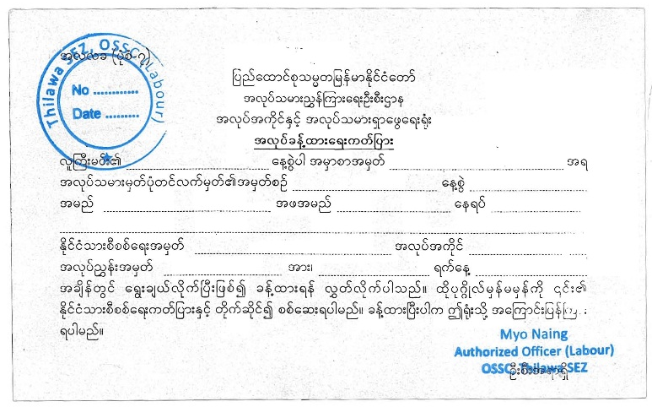

Figure [1]: Front View of Registration Card (Local Worker)

Figure [2]: Rear View of Registration Card (Local Worker)

